DESIGN AND IMPLEMENTATION OF SELF NAVIGATING AUTONOMOUS ROBOT WITH 2D-MAPPING USING ARDUINO
A project report submitted in partial fulfillment of the requirements for
the award of the degree of
BACHELOR OF ENGINEERING
IN
ELECTRONICS AND COMMUNICATION ENGINEERING
Submitted by
Karne Shiva Sai 160115735114

Under the esteemed guidance of
Dr. D Krishna Reddy

Professor, ECE DEPT, CBIT

Submitted to
Department of Electronics and Communication Engineering
Chaitanya Bharathi Institute of Technology (Autonomous)
Gandipet, Hyderabad- 500 075
2018-2019



CERTIFICATE
This is to certify that the project report entitled “ DESIGN AND IMPLEMENTATION OF SELF NAVIGATING AUTONOMOUS ROBOT WITH 2D-MAPPING USING ARDUINO” being submitted by
K. Shiva Sai 160115735114

in partial fulfillment for the award of the Degree of Bachelor of Engineering in Electronics and Communication Engineering from Chaitanya Bharathi Institute of Technology (A), affiliated to Osmania University is a record of bonafide work carried out by them under the guidance and supervision of Dr.D.Krishna Reddy, Professor, ECE dept., during the academic year 2018-19.

PROJECT GUIDE AND HEAD OF DEPARTMENT EXTERNAL EXAMINER
Dr. D. Krishna Reddy
Professor, Head of the Dept.,
Dept. of ECE,
CBIT, Hyderabad.
DECLARATION
This is to certify that the work reported on the present project entitled “DESIGN AND IMPLEMENTATION OF SELF NAVIGATING AUTONOMOUS ROBOT WITH 2D-MAPPING USING ARDUINO” is a record of work done by us in the Department of Electronics and Communication Engineering, Chaitanya Bharathi Institute of Technology. This report is based on the project work done entirely by us and any information procured from resources has been mentioned in the References.

K. Shiva Sai 160115735114

ACKNOWLEDGEMENT
The satisfaction that accomplishes the successful completion of any task would be incomplete without the mention of the people who make it possible and whose constant guidance and encouragement crown all the efforts with success.
First and foremost, I sincerely express our thanks to Dr. P. RAVINDER REDDY, Principal, Chaitanya Bharathi Institute of Technology, Hyderabad, for providing all the facilities required completion of this task.
I wish to express my gratitude to Dr. D. KRISHNA REDDY, Professor, HOD of ECE, and also our project guide for his valuable suggestions and encouragement throughout the project.
We are very grateful to our M.V. NAGABHUSHANAM project Coordinator, Associate Professor, CBIT for their constant monitoring, administrative help and cooperation throughout the project.
And also, to all the teaching and non-teaching staff and my friends for their good wishes, their helping hands and constructive criticism, which led the successful completion of project. Finally, we thank to those all directly and indirectly helped us in this regard; we apologize for not listing everyone here.

K. Shiva Sai 160115735114

ABSTRACT
This paper presents the design and implementation of self-navigating autonomous robot with 2d-mapping using arduino. The concept of mobile mapping robot is fast evolving and their complexities are increasing with different applications. For this project we use arduino cc IDE to interface our arduino chip.
The main aim of this project is to design a circuit which interfaces the sensors with the driving motors using arduino. We use three ultrasonic sensors in three different directions to find the path which is clear of obstacles. We use a dual-motor driver to interface the arduino with four 9 volts dc motors to drive the robot. A 3 axis digital compass is used to map the direction in which the robot is headed in 2D format.
The methodology employed in this project is by finding the relative distance between the ultrasonic sensor which is a non-contact based measurement system and the reflecting surface. A sonic burst from the sensor is sent to find the obstacles and the echo will be received in a certain time. The robot compares the distances of left and right directions and powers the respective motors. The compass gives the heading degree for every instance of time and all the required information to map the surroundings in MATLAB is made available to the user using wireless communication ZIGBEE from robot to the user’s PC or LAPTOP.

INDEX
TOPICS
- Certificates
- Acknowledgement
CHAPTER 1: INTRODUCTION
  - Introduction of the project
  - Project overview
  - Aim and Objectives
  - Motivation
  - Embedded systems
  - Thesis
CHAPTER 2: HARDWARE DESCRIPTION
2.1 Introduction with block diagram
2.2 Arduino UNO with ATMEGA328P
2.3 12V Rechargable battery
2.4 Digital Compass HMC5883L
2.5 DC motor
2.6 L298 motor driver
2.7 Ultrasonic Sensor HCSR04
2.8 ZIGBEE
CHAPTER 3: SOFTWARE DESCRIPTION
3.1 ARDUINO IDE Compiler
3.2 MATLAB software
CHAPTER 4: PROJECT DESCRIPTION
4.1 SCHEMATIC DIAGRAM
4.2 METHODOLOGY
CHAPTER 5:
5.1 RESULTS
5.2 CONCLUSION
CHAPTER 6:
6.1 LIMITATIONS
6.2 FUTURE SCOPE

REFERENCES

APPENDIX

LIST OF FIGURES
Figure no: Description of figure Page no.
1.1: A modern example of embedded system
1.2: Applications of Embedded Systems
2.1: Block diagram of robot section
2.2: Block diagram of PC section
2.3: An official Arduino Uno R2 with descriptions of the I/O locations
2.4: PDIP of ATMEGA 328P
2.5:Rechargeable battery
2.6: Charging circuit
2.7: Digital compass
2.8: DC Motor
2.9: Simple electrical diagram of DC motor
2.10: Operation of a DC Motor

2.11: L298N motor driver
2.12: Working of ultrasonic sensors
2.13: IEEE 802.15.4 / ZigBee Stack Architecture
2.14: Possible network topologies in ZIGBEE
3.1: Using arduino ide compiler for compiling , debugging and dumping the code into microcontroller board.
3.2: New editor window
Figure no. Description of figure Page no.
3.3: HELP command in MATLAB
3.4: Plotting between 2 variables with labeling in MATLAB
4.1: Schematic diagram
4.2: Receiver
4.3: flowchart describing the behaviour of the robot when it is faces an obstacle
5.1: Data received by the laptop
5.2:The result map
5.3 ROBOT DESIGN

LIST OF TABLES
Table no. Description of Table Page no. 2.1: Parameter of ATMEGA328P
2.2 Comparison between ATmega48PA, ATmega88PA, ATmega168PA and ATmega328P
3.1 Matlab graphics

CHAPTER 1
INTRODUCTION
  - Introduction
To design a path finding robot with moderate velocity and to map the unknown environment using ARDUINO.
Ultrasonic sensors (also known as transceivers when they both send and receive, but more generally called transducers) work on a principle similar to radar or sonar which evaluates attributes of a target by interpreting the echoes from radio or sound waves respectively. Ultrasonic sensors generate high frequency sound waves and evaluate the echo which is received back by the sensor. Sensors calculate the time interval between sending the signal and receiving the echo to determine the distance to an object.
The controlling device of the whole system is a Arduino. The Arduino reads the ultrasonic sensors data regarding the obstacle detected. Robot moves in the same direction until it reaches another turn. To perform this intelligent navigation, the Arduino is loaded with an efficient program written using embedded ‘C’ language.
Here we are using zigbee technology for data communication. The arduino microcontroller continuously monitors the path of vehicle through the ultrasonic sensor and this Information sends to the pc through zigbee technology. Meanwhile the MATLAB code is run in the PC. So we can know the TRAVELED PATH MAP on PC through MATLAB.
1.2 Project Overview
An embedded system is a combination of software and hardware to perform a dedicated task. Some of the main devices used in embedded products are Microprocessors and Microcontrollers.
Microprocessors are commonly referred to as general purpose processors as they simply accept the inputs, process it and give the output. In contrast, a microcontroller not only accepts the data as inputs but also manipulates it, interfaces the data with various devices, controls the data and thus finally gives the result.
The project “SELF NAVIGATING AUTONOMOUS ROBOT WITH 2D-MAPPING USING ARDUINO” aims at developing an intelligently navigable Robot using obstacle sensors and Digital compass. And also wireless communication using ZIGBEE technology. To do this particular task using arduino written in embedded c language and PC with MATLAB.

1.3 Aim and objectives
The aim of the project is to design an autonomous robot which navigates itself in an unknown path and gives a 2D map of the path in which it has travelled.
The objectives are
- To find path free of obstacles using ultra-sonic sensors.
- To find the safest path around with arduino by comparing the outputs of various sensors.
- To transfer the data required to map the surroundings in 2D format by using a Zigbee.
- Using MATLAB software to process the data acquired by Zigbee receiver to obtain the 2D map in pc/laptop.
1.4. Motivation
There are many integration techniques to increase the efficiency of GPS as the remote areas could not receive from all the 4 GPS satellites. These remote areas mostly cannot be seen properly. Hence we require an autonomous navigation system which guides a robot mounted by sensors to map the unknown environment.
Currently, different algorithms exists to solve the problems of robot localization, goal recognition and path planning for a mobile robot navigating indoors and it is fair to say that the majority of the past research has focused on navigation in structured environments. Still, the problem of navigation is one that is not completely solved yet.
1.5. Embedded Systems
An embedded system is a computer system designed to perform one or a few dedicated functions often with real-time computing constraints. It is embedded as part of a complete device often including hardware and mechanical parts. By contrast, a general-purpose computer, such as a personal computer (PC), is designed to be flexible and to meet a wide range of end-user needs. Embedded systems control many devices in common use today.
Embedded systems are controlled by one or more main processing cores that are typically either microcontrollers or digital signal processors (DSP). The key characteristic, however, is being dedicated to handle a particular task, which may require very powerful processors. For example, air traffic control systems may usefully be viewed as embedded, even though they involve mainframe computers and dedicated regional and national networks between airports and radar sites. (Each radar probably includes one or more embedded systems of its own.)
Since the embedded system is dedicated to specific tasks, design engineers can optimize it to reduce the size and cost of the product and increase the reliability and performance. Some embedded systems are mass-produced, benefiting from economies of scale.
Physically embedded systems range from portable devices such as digital watches and MP3 players, to large stationary installations like traffic lights, factory controllers, or the systems controlling nuclear power plants. Complexity varies from low, with a single microcontroller chip, to very high with multiple units, peripherals and networks mounted inside a large chassis or enclosure.
In general, "embedded system" is not a strictly definable term, as most systems have some element of extensibility or programmability. For example, handheld computers share some elements with embedded systems such as the operating systems and microprocessors which power them, but they allow different applications to be loaded and peripherals to be connected. Moreover, even systems which don't expose programmability as a primary feature generally need to support software updates. On a continuum from "general purpose" to "embedded", large application systems will have subcomponents at most points even if the system as a whole is "designed to perform one or a few dedicated functions", and is thus appropriate to call "embedded". A modern example of embedded system is shown in fig: 1.1.
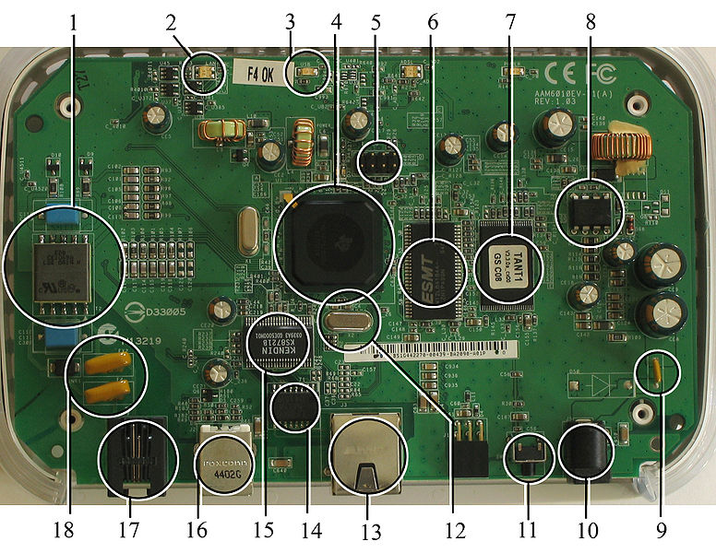
Figure 1.1:A modern example of embedded system
Labeled parts include microprocessor (4), RAM (6), flash memory (7).Embedded systems programming is not like normal PC programming. In many ways, programming for an embedded system is like programming PC 15 years ago. The hardware for the system is usually chosen to make the device as cheap as possible. Spending an extra dollar a unit in order to make things easier to program can cost millions. Hiring a programmer for an extra month is cheap in comparison. This means the programmer must make do with slow processors and low memory, while at the same time battling a need for efficiency not seen in most PC applications. Below is a list of issues specific to the embedded field.
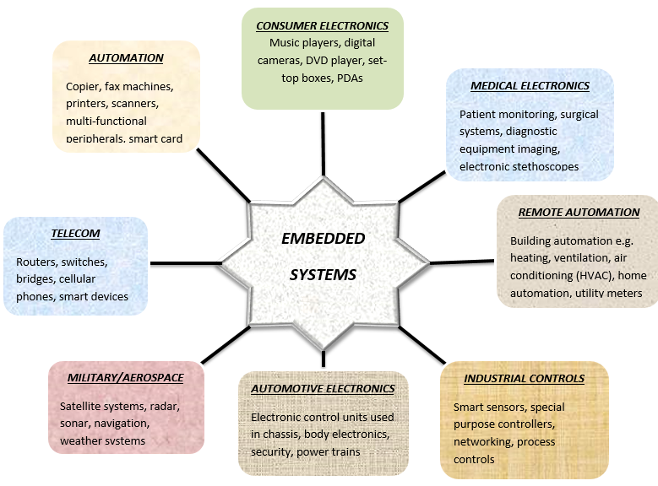
Figure 1.2 Applications of Embedded Systems

1.6 Thesis
The thesis explains the implementation of “SELF NAVIGATING AUTONOMOUS ROBOT WITH 2D-MAPPING USING ARDUINO”. The organization of the thesis is explained here with:
Chapter 1 Presents introduction to the overall thesis and the overview of the project
Chapter 2 Presents the hardware description. It deals with the block diagram of the project and explains the purpose of each block.
Chapter 3 Presents the software description. It explains the implementation of the project using Arduino IDE studio Compiler software along with MATLAB.
Chapter 4 Presents the project description.
Chapter 5 Presents the advantages, disadvantages and applications of the project.
Chapter 6 Presents the results, conclusion and future scope of the project.

CHAPTER 2
HARDWARE DESCRIPTION
2.1 Introduction with block diagram
In this chapter the block diagram of the project and design aspect of independent modules are considered. Block diagram is shown in figure 2.1:
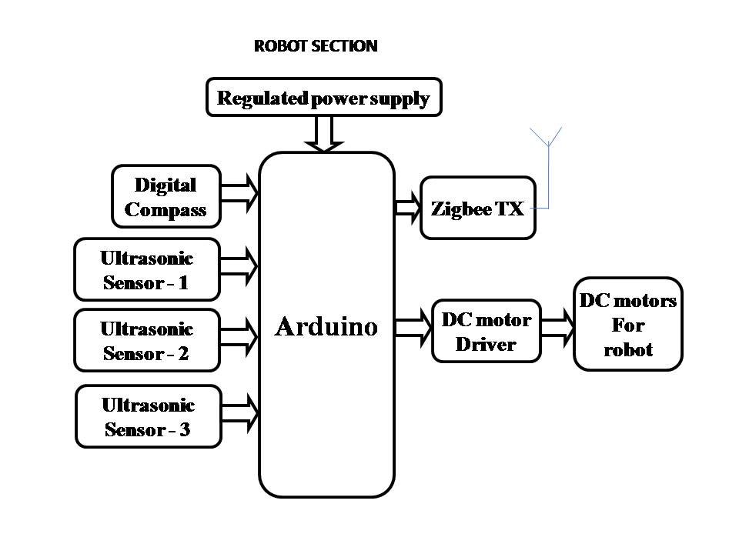
Figure 2.1: Block diagram of robot section
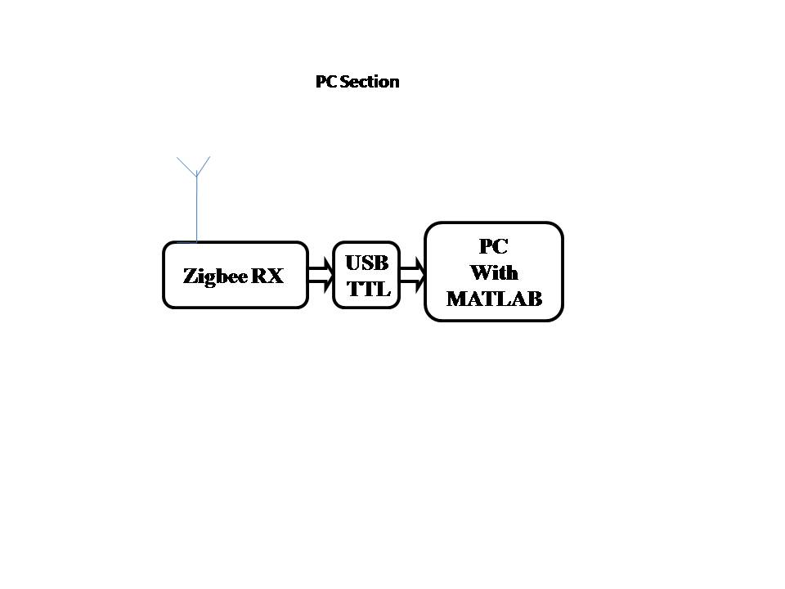
Figure 2.2: Block diagram of PC section
The main blocks of this project are:
- Regulated power supply with voltage regulator.
- Digital Compass.
- Arduino.
- Zigbee Tx,Rx.
- DC motors with driver.
- Ultrasonic sensors.
2.2 ARDUINO UNO WITH ATMEGA328
Arduino is an open source, computer hardware and software company, project, and user community that designs and manufactures microcontroller kits for building digital devices and interactive objects that can sense and control objects in the physical world. aArduino boards are available commercially in preassembled form, or as do-it-yourself kits.
Arduino board designs use a variety of microprocessors and controllers. The boards are equipped with sets of digital and analog input/output (I/O) pins that may be interfaced to various expansion boards (shields) and other circuits. The boards feature serial communications interfaces, including Universal Serial Bus (USB) on some models, which are also used for loading programs from personal computers. The microcontrollers are typically programmed using a dialect of features from the programming languages C and C++. In addition to using traditional compiler toolchains, the Arduino project provides an integrated development environment (IDE) based on the Processing language project.
The Arduino project started in 2003 as a program for students at the Interaction Design Institute Ivrea in Ivrea, Italy, aiming to provide a low-cost and easy way for novices and professionals to create devices that interact with their environment using sensors and actuators. Common examples of such devices intended for beginner hobbyists include simple robots, thermostats, and motion detectors.
The name Arduino comes from a bar in Ivrea, Italy, where some of the founders of the project used to meet. The bar was named after Arduin of Ivrea, who was the margrave of the March of Ivrea and King of Italy from 1002 to 1014
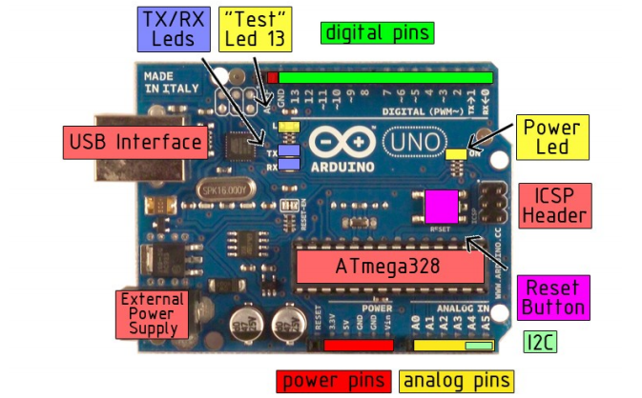
Figure 2.3:An official Arduino Uno R2 with descriptions of the I/O locations
The Arduino board exposes most of the microcontroller's I/O pins for use by other circuits. The Diecimila, Duemilanove, and current Uno provide 14 digital I/O pins, six of which can produce pulse-width modulated signals, and six analog inputs, which can also be used as six digital I/O pins. These pins are on the top of the board, via female 0.1-inch (2.54 mm) headers. Several plug-in application shields are also commercially available. The Arduino Nano, and Arduino-compatible Bare Bones Board and Boarduino boards may provide male header pins on the underside of the board that can plug into solderless breadboards.
Many Arduino-compatible and Arduino-derived boards exist. Some are functionally equivalent to an Arduino and can be used interchangeably. Many enhance the basic Arduino by adding output drivers, often for use in school-level education, to simplify making buggies and small robots. Others are electrically equivalent but change the form factor, sometimes retaining compatibility with shields, sometimes not. Some variants use different processors, of varying compatibility.
ATMEGA328:
Table 2.1:Parameter of ATMEGA328P
Parameter | Value
Operating Voltage | 1.8 - 5.5V
Temperature Range | -40°C to 85°C
Speed Grade | 0 - 20 MHz @ 1.8 - 5.5V
CPU type | 8-bit AVR
Performance | 20 MIPS at 20 MHz
Flash memory | 32 Kb
SRAM | 2 kB
EEPROM | 1 kB
Pin count | 28 or 32 pin: PDIP-28, MLF-28, TQFP-32, MLF-32
Maximum operating frequency | 20 MHz
Number of touch channels | 16
Hardware QTouch Acquisition | No
Maximum I/O pins | 23
External interrupts | 2

Features
• High Performance, Low Power AVR® 8-Bit Microcontroller
• Advanced RISC Architecture
– 131 Powerful Instructions – Most Single Clock Cycle Execution
– 32 x 8 General Purpose Working Registers
– Fully Static Operation
– Up to 20 MIPS Throughput at 20 MHz
– On-chip 2-cycle Multiplier
• Peripheral Features
– Two 8-bit Timer/Counters with Separate Prescaler and Compare Mode
– One 16-bit Timer/Counter with Separate Prescaler, Compare Mode, and Capture
• Special Microcontroller Features
– Power-on Reset and Programmable Brown-out Detection
– Internal Calibrated Oscillator
– External and Internal Interrupt Sources
– Six Sleep Modes: Idle, ADC Noise Reduction, Power-save, Power-down, Standby,
and Extended Standby
• Low Power Consumption at 1 MHz, 1.8V, 25°C for ATmega48PA/88PA/168PA/328P:
– Active Mode: 0.2 mA
– Power-down Mode: 0.1 μA
–Power-save Mode: 0.75 μA (Including 32 kHz RTC)
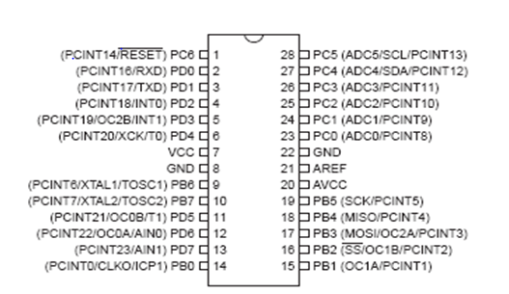
Figure 2.4:PDIP of ATMEGA 328P
Overview
The ATmega48PA/88PA/168PA/328P is a low-power CMOS 8-bit microcontroller based on the AVR enhanced RISC architecture. By executing powerful instructions in a single clock cycle, the ATmega48PA/88PA/168PA/328P achieves throughputs approaching 1 MIPS per MHz allowing the system designer to optimize power consumption versus processing speed.
Table 2.2 Comparison between ATmega48PA, ATmega88PA, ATmega168PA and ATmega328P
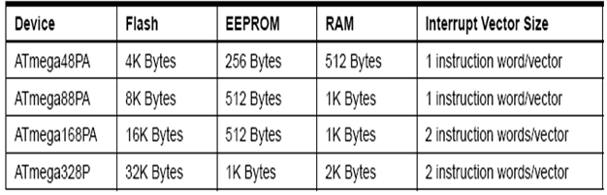

The ATmega48PA, ATmega88PA, ATmega168PA and ATmega328P differ only in memory sizes, boot loader support, and interrupt vector sizes. Table 2-1 summarizes the different memory and interrupt vector sizes for the three devices.
2.3. 12V RECHARGABLE BATTERY WITH CHARGING CIRCUIT

Rechargeable battery:
A rechargeable battery, storage battery, or accumulator is a type of electrical battery. It comprises one or more electrochemical cells, and is a type of energy accumulator. It is known as a secondary cell because its electrochemical reactions are electrically reversible. Rechargeable batteries come in many different shapes and sizes, ranging from button cells to megawatt systems connected to stabilize an electrical distribution network. Several different combinations of chemicals are commonly used, including: lead–acid, nickel cadmium (NiCd), nickel metal hydride (NiMH), lithium ion (Li-ion), and lithium ion polymer (Li-ion polymer).
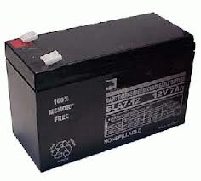
Figure 2.5:Rechargeable battery
Rechargeable batteries have lower total cost of use and environmental impact than disposable batteries. Some rechargeable battery types are available in the same sizes as disposable types. Rechargeable batteries have higher initial cost but can be recharged very cheaply and used many times.
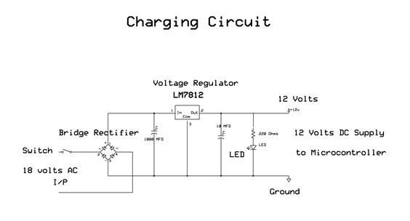
Figure 2.6: Charging circuit

From the above circuit diagram, we can see that the 18v AC is being converted to 18V pulsating DC which is in turn converted to smooth DC with the help of the Capacitor. This 18V Smooth DC is converted to 12V DC by the Voltage Regulator 7812. At the output of the regulator, we get some spikes which are not desirable. These spikes are removed with the help of another capacitor used. We can get 12V.
2.4 Digital Compass
HMC5883L
The HMC5883L utilizes Anisotropic Magneto resistive (AMR) technology that provides advantages over other magnetic sensor technologies. These anisotropic, directional sensors feature precision in-axis sensitivity and linearity. These sensors solid-state construction with very low cross-axis sensitivity is designed to measure both the direction and the magnitude of Earth’s magnetic fields. Honeywell’s Magnetic Sensors are among the most sensitive and reliable low-field sensors in the industry.
FEATURES
- 3-Axis magneto-resistive sensor
- 1 to 2 degree compass heading accuracy
- Wide magnetic field range (+/-8 gauss)
- Fast 160 Hz maximum output rate
- Precision in-axis sensitivity and linearity
- Measures Earth’s magnetic field, from milli-gauss to 8 gauss
KEY SPECIFICATIONS
- Power Requirements: 2.7 to 6.5 VDC
- Communication Interface: I²C (up to 400 kHz)
- Operating temperature: -22 to +185 °F (-30 to +85 °C)
- Dimensions: 0.73 x .65 in ( 1.8 x 1.7 cm)
APPLICATION IDEAS
- Auto and personal navigation
- Robotic navigation
- Location-based services (LBS)
PIN DESCRIPTION
1 GND: Ground
2 VIN: Power Supply Voltage – 2.7 to 6.5 VDC (module is regulated to 2.5VDC)
3 DRDY: Data Ready, interrupt.
4 SCL: I²C Clock
5 SDA: I²C Data
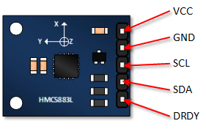
Figure 2.7: Digital compass
2.5. D.C. Motor
For driving the robot dc motors of 12v can be used. Since the robot has two main wheels and one free wheel, two motors are fixed to the two wheels. The speed of the motor depends upon the voltage supplied from the battery. The speed of the motors can be controlled by using the Pulse width modulation (PWM) pins of the controller i.e., by adjusting the duty cycle of the PWM pins.
These motors are connected to the controller via the motor driver. These drive the robot as per the decision taken by the robot during the navigation i.e., to forward or right side or left side. The dc motors output shaft is connected to the wheels. Geared DC motors are shown below in the figure 2.5
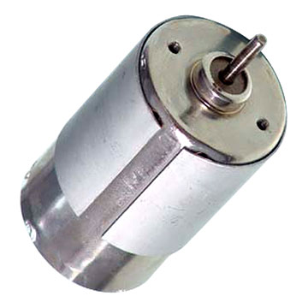
Figure 2.8: DC Motor
Operation:
The DC motor you will find in modem industrial applications operates very similarly to the simple DC motor described earlier in this chapter. Figure 12-9 shows an electrical diagram of a simple DC motor. Notice that the DC voltage is applied directly to the field winding and the brushes. The armature and the field are both shown as a coil of wire. In later diagrams, a field resistor will be added in series with the field to control the motor speed.
When voltage is applied to the motor, current begins to flow through the field coil from the negative terminal to the positive terminal. This sets up a strong magnetic field in the field winding. Current also begins to flow through the brushes into a commutator segment and then through an armature coil. The current continues to flow through the coil back to the brush that is attached to other end of the coil and returns to the DC power source. The current flowing in the armature coil sets up a strong magnetic field in the armature.

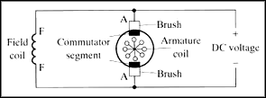
Figure 2.9: Simple electrical diagram of DC motor
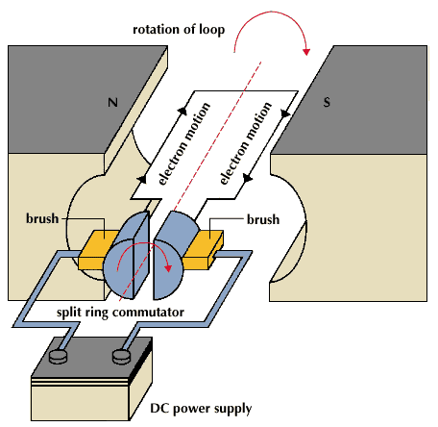
Figure 2.10: Operation of a DC Motor
The magnetic field in the armature and field coil causes the armature to begin to rotate. This occurs by the unlike magnetic poles attracting each other and the like magnetic poles repelling each other. As thearmature begins to rotate, the commutator segments will also begin to move under the brushes. As an individual commutator segment moves under the brush connected to positive voltage, it will become positive, and when it moves under a brush connected to negative voltage it will become negative. In this way, the commutator segments continually change polarity from positive to negative. Since the commutator segments are connected to the ends of the wires that make up the field winding in the armature, it causes the magnetic field in the armature to change polarity continually from north pole to south pole. The commutator segments and brushes are aligned in such a way that the switch in polarity of the armature coincides with the location of the armature's magnetic field and the field winding's magnetic field. The switching action is timed so that the armature will not lock up magnetically with the field. Instead the magnetic fields tend to build on each other and provide additional torque to keep the motor shaft rotating.
When the voltage is de-energized to the motor, the magnetic fields in the armature and the field winding will quickly diminish and the armature shaft's speed will begin to drop to zero. If voltage is applied to the motor again, the magnetic fields will strengthen and the armature will begin to rotate again.

2.6 L298N Motor driver circuit
Motors are not directly connected to the controller but they are connected with the help of motor drivers to isolate the controller circuit from the motor circuitry. The driver circuitry used is L298N.
The L298 is an integrated monolithic circuit in a 15- lead Multiwatt and PowerSO20 packages. It is a high voltage, high current dual full-bridge driver designed to accept standard TTL logic levels and drive inductive loads such as relays, solenoids, DC and stepping motors.
L298N is used as a driver for the robot. Enable pins and input pins on it can be used by the microcontroller for controlling the direction and speed. The circuit can drive two motors. It has 5v onboard regulator. If the supply voltage to the driver circuit is less than or equal to 12v, the 5v IN/OUT pin acts an output pin which can be used for driving the microcontroller. In the above case you need not to remove the 12v jumper. But if the input to the driver circuit is greater than 12v, the 12v jumper should be removed in order to protect the 5v onboard regulator and the 5v IN/OUT pin act as an input pin. The pins on the L298N are shown in the figure 2.6
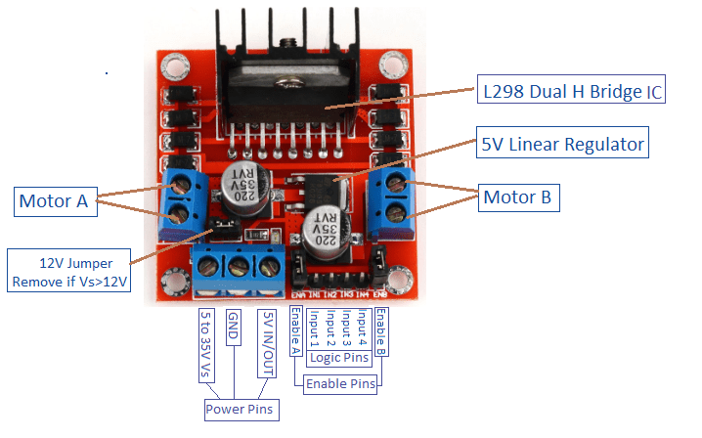

Figure 2.11 L298N motor driver

2.7. Ultra sonic sensors HCSR04
Driving the robot to the destination will have many difficulties. The major problem comes when the robot faces an obstacle in its path. To encounter this there are few methods which employs the use of various sensors. An ultrasonic sensor is used for the detection of the obstacle in its path.
These sensors are fixed to the head of the robot in front, right and left directions. They are interfaced to the microcontroller. The sensor consists of transmitter and the receiver. With the help of ultrasonic waves transmitted from the sensors we can find time elapsed between the start time of transmitting and receiving the waves if any obstacle. Hence we can estimate the distance of the obstacle from the robot. With the help of this information robot can take the decisions to turn away from the obstacle.
HCSR04 (Ultra sonic sensor) consists of four pins as shown in the figure 2.7 .They are
  - Vcc
  - Trigger
  - Echo
  - Ground
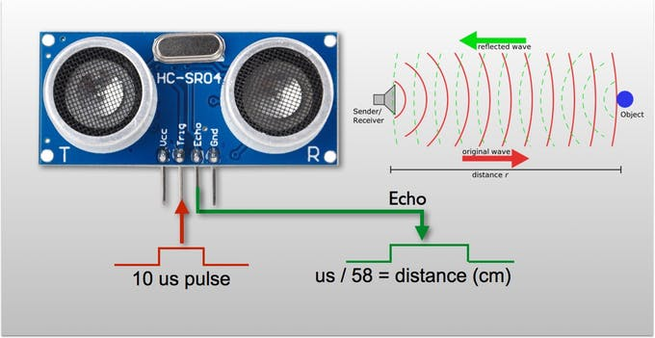

Figure 2.12 Working of ultrasonic sensors

Specifications of HCSR04
- Working voltage : 5v
- Working current : 15mA
- Frequency: 40 Hz
- Maximum range: 4m
- Minimum range: 2m
- Measuring angle: 15 degrees
- Trigger input signal: 10 micro seconds pulse
- Echo signal: 10 micro seconds TTL level signal and the range is proportional
Applications:
Ultrasonic sensors are ideally suited to accurate, automatic distance measurement in normal and difficult environments. Ultrasonic sensors are particularly suitable for environments where optical sensors are unusable such as smoke, dust and similar. Ultrasonic sensors are very accurate, stable and can be used over large ranges.
2.8 Zigbee
Zigbee technology Introduction:
ZigBee is an established set of specifications for wireless personal area networking (WPAN), i.e., digital radio connections between computers and related devices. This kind of network eliminates use of physical data buses like USB and Ethernet cables. The devices could include telephones, hand-held digital assistants, sensors and controls located within a few meters of each other.
ZigBee is one of the global standards of communication protocol formulated by the relevant task force under the IEEE 802.15 working group. The fourth in the series, WPAN Low Rate/ZigBee is the newest and provides specifications for devices that have low data rates, consume very low power and are thus characterized by long battery life. Other standards like Blue tooth and IrDA address high data rate applications such as voice, video and LAN communications.
The ZigBee Alliance has been set up as “an association of companies working together to enable reliable, cost-effective, low-power, wirelessly networked, monitoring and control products based on an open global standard”.
Once a manufacturer enrolls in this Alliance for a fee, he can have access to the standard and implement it in his products in the form of ZigBee chipsets that would be built into the end devices. Philips, Motorola, Intel, HP are all members of the Alliance. The goal is “to provide the consumer with ultimate flexibility, mobility, and ease of use by building wireless intelligence and capabilities into every day devices.
ZigBee technology will be embedded in a wide range of products and applications across consumer, commercial, industrial and government markets worldwide. For the first time, companies will have a standards-based wireless platform optimized for the unique needs of remote monitoring and control applications, including simplicity, reliability, low-cost and low-power”.
Architecture:
Though WPAN implies a reach of only a few meters, 30 feet in the case of ZigBee, the network will have several layers, so designed as to enable interpersonal communication within the network, connection to a network of higher level and ultimately an uplink to the Web.

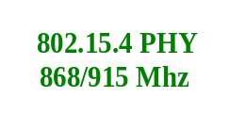
802.15.4 MAC
ZigBee Application layer

ZigBee Network layer

802.15.4 PHY
2.4 GHz

802.15.4 MAC

I
E
E
E

Figure 2.11 Zigbee
802.15.4 / ZigBee Architecture
1. Network and Application Support layer:
The network layer permits growth of network sans high power transmitters. This layer can handle huge numbers of nodes. This level in the ZigBee architecture includes the ZigBee Device Object (ZDO), user-defined application profile(s) and the Application Support (APS) sub-layer.
The APS sub-layer's responsibilities include maintenance of tables that enable matching between two devices and communication among them, and also discovery, the aspect that identifies other devices that operate in the operating space of any device.
2. Media access control (MAC) layer:
The IEEE802.15.4 MAC media access control layer permits use of several topologies without introducing complexity and is meant to work with large numbers of devices.
3. Physical (PHY) layer:
The IEEE802.15.4 PHY physical layer accommodates high levels of integration by using direct sequence to permit simplicity in the analog circuitry and enable cheaper implementations.
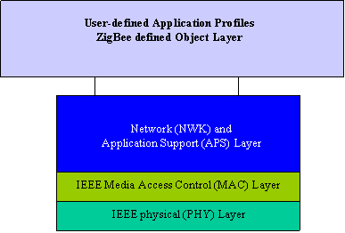
Figure 2.13: IEEE 802.15.4 / ZigBee Stack Architecture
ZigBee Characteristics:
The focus of network applications under the IEEE 802.15.4 / ZigBee standard include the features of low power consumption, needed for only two major modes (Tx/Rx or Sleep), high density of nodes per network, low costs and simple implementation.
These features are enabled by the following characteristics:
• 2.4GHz and 868/915 MHz dual PHY modes. This represents three license-free bands: 2.4-2.4835 GHz, 868-870 MHz and 902-928 MHz. The number of channels allotted to each frequency band is fixed at sixteen (numbered 11-26), one (numbered 0) and ten (numbered 1-10) respectively. The higher frequency band is applicable worldwide, and the lower band in the areas of North America, Europe, Australia and New Zealand.
• Low power consumption, with battery life ranging from months to years. Considering the number of devices with remotes in use at present, it is easy to see that more numbers of batteries need to be provisioned every so often, entailing regular (as well as timely), recurring expenditure. In the ZigBee standard, longer battery life is achievable by either of two means: continuous network connection and slow but sure battery drain, or intermittent connection and even slower battery drain.
• Maximum data rates allowed for each of these frequency bands are fixed as 250 kbps @2.4 GHz, 40 kbps @ 915 MHz, and 20 kbps @868 MHz.
• High throughput and low latency for low duty-cycle applications (<0.1%)
• Channel access using Carrier Sense Multiple Access with Collision Avoidance (CSMA - CA)
• Addressing space of up to 64 bit IEEE address devices, 65,535 networks
• 50m typical range
• Fully reliable “hand-shacked” data transfer protocol.
• Different topologies as illustrated below: star, peer-to-peer, mesh
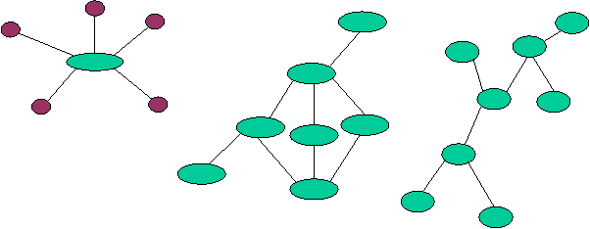
Figure 2.14 Possible network topologies in ZIGBEE
Traffic Types:
ZigBee/IEEE 802.15.4 addresses three typical traffic types. IEEE 802.15.4 MAC can accommodate all the types.
1. Data is periodic: The application dictates the rate, and the sensor activates checks for data and deactivates.
2. Data is intermittent: The application, or other stimulus, determines the rate, as in the case of say smoke detectors. The device needs to connect to the network only when communication is necessitated. This type enables optimum saving on energy.
3. Data is repetitive: The rate is fixed a priori. Depending on allotted time slots, called GTS (guaranteed time slot), devices operate for fixed durations.
ZigBee Applications
The ZigBee Alliance targets applications "across consumer, commercial, industrial and government markets worldwide".
Unwired applications are highly sought after in many networks that are characterized by numerous nodes consuming minimum power and enjoying long battery lives.
ZigBee technology is designed to best suit these applications, for the reason that it enables reduced costs of development, very fast market adoption, and rapid ROI.
With ZigBee designed to enable two-way communications, not only will the consumer be able to monitor and keep track of domestic utilities usage, but also feed it to a computer system for data analysis.

CHAPTER 3
SOFTWARE DESCRIPTION
This project is implemented using following software’s:
- Arduino IDE compiler - for navigation part
- Matlab – for mapping part
3.1. Arduino IDE Compiler:
The Arduino integrated development environment (IDE) is a cross-platform applications that is written in the programming language Java. It is used to write and upload programs to Arduino compatible boards, but also, with the help of 3rd party cores, other vendor development boards.
The source code for the IDE is released under the general public license, version 2. The Arduino IDE supports the languages C and C++ using special rules of code structuring. The Arduino IDE supplies a software library from the Wiring project, which provides many common input and output procedures. User-written code only requires two basic functions, for starting the sketch and the main program loop, that are compiled and linked with a program stub main() into an executable cyclic executive program with the GNU toolchain, also included with the IDE distribution.^{[5]} The Arduino IDE employs the program avrdude to convert the executable code into a text file in hexadecimal encoding that is loaded into the Arduino board by a loader program in the board's firmware
We develop the code in this software and constantly check for errors. If any, the compiler asks them to rectify and the process goes on until we find the desired operation from the robot.
This software provides you the facility to add new libraries which carries special functions, which when called repeatedly decreases the code length and saves some ROM in the microcontroller, useful to perform other operations.

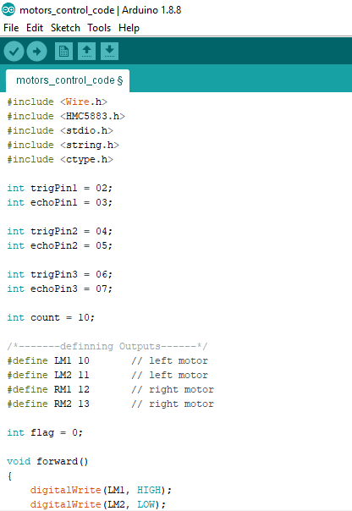
Figure 3.1. Using arduino ide compiler for compiling , debugging and dumping the code into microcontroller board.

3.2. MATLAB
MATLAB INTRODUCTION:
The name MATLAB stands for matrix laboratory. MATLAB (matrix laboratory) is a numerical computing environment and fourth-generation programming language. Developed by MathWorks, MATLAB allows matrix manipulations, plotting of functions and data, implementation of algorithms, creation of user interfaces, and interfacing with programs written in other languages, including C, C++, Java, and Fortran.
MATLAB can be used in a wide range of applications, including signal and image processing, communications, control design, test and measurement, financial modeling and analysis, and computational biology. For a million engineers and scientists in industry and academia, MATLAB is the language of technical computing.
The MATLAB System
The MATLAB system consists of five main parts:

The MATLAB language.
This is a high-level matrix/array language with control flow statements, functions, data structures, input/output, and object-oriented programming features. It allows both "programming in the small" to rapidly create quick and dirty throw-away programs, and "programming in the large" to create complete large and complex application programs.

The MATLAB working environment.
This is the set of tools and facilities that you work with as the MATLAB user or programmer. It includes facilities for managing the variables in your workspace and importing and exporting data.
It also includes tools for developing, managing, debugging, and profiling M-files, MATLAB's applications.

Handle Graphics.
This is the MATLAB graphics system. It includes high-level commands for two-dimensional and three-dimensional data visualization, image processing, animation, and presentation graphics. It also includes low-level commands that allow you to fully customize the appearance of graphics as well as to build complete Graphical User Interfaces on your MATLAB applications.

The MATLAB mathematical function library.
This is a vast collection of computational algorithms ranging from elementary functions like sum, sine, cosine, and complex arithmetic, to more sophisticated functions like matrix inverse, matrix eigenvalues, Bessel functions, and fast Fourier transforms.

The MATLAB Application Program Interface (API).
This is a library that allows you to write C and Fortran programs that interact with MATLAB. It include facilities for calling routines from MATLAB (dynamic linking), calling MATLAB as a computational engine, and for reading and writing MAT-files.
HOW TO START MATLAB
MATLAB is started by clicking the mouse on the appropriate icon and is ended by typing exit or by using the menu option. After each MATLAB command return or enter key must be pressed.
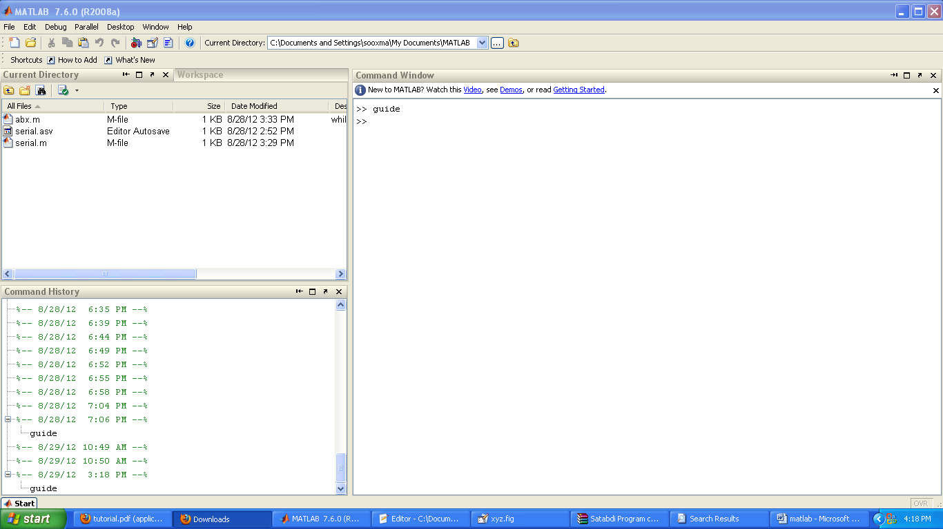
Figure 3.2: New editor window
For any help regarding MATLAB just type doc help on MATLAB command window. And this editor window will be opened. Now you have to type the name of the particular field you are searching for. And you will get all the information regarding that fig 3.2.1.
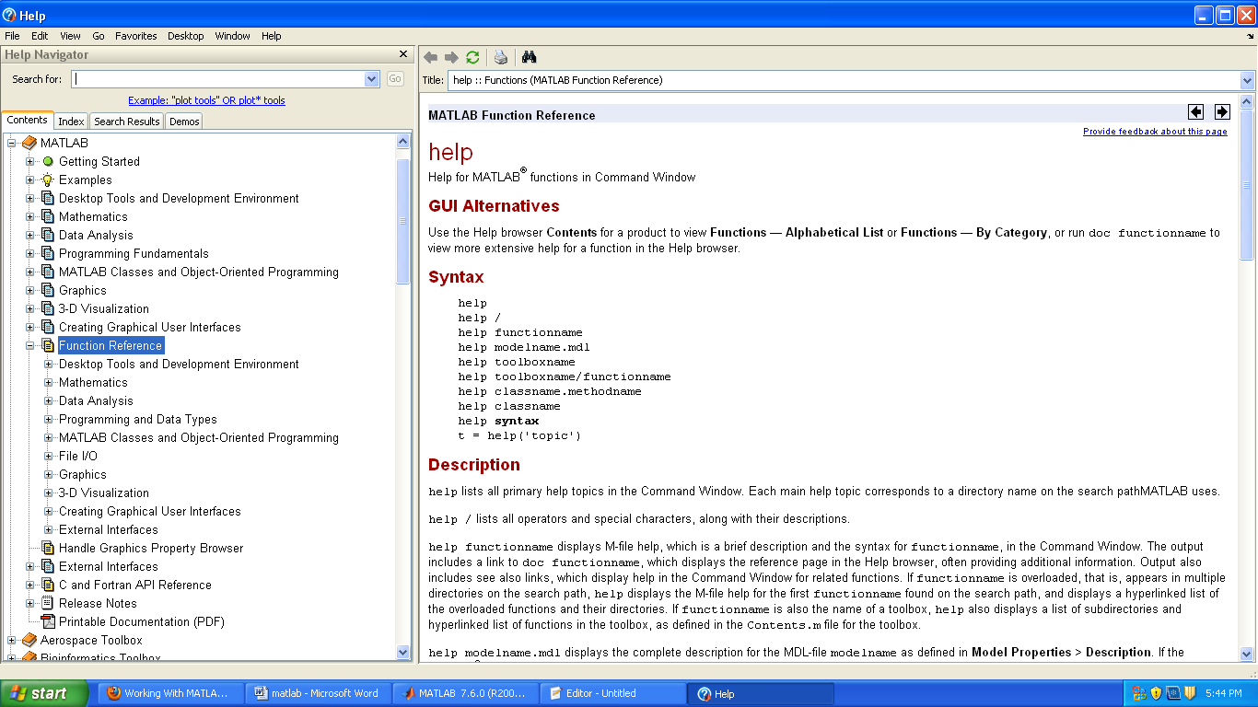
.Figure 3.3: HELP command in MATLAB
- Creating Variables:
x=5.71;
- Creating String:
Mystring= ’Hello, world’
- Mathematical use
Mathematical symbols
‘+’=Addition
‘-‘=Subtraction
‘*’=Multiplication
‘/’=Division
^ = Power operator
' = Transpose
Mathematical Functions:
sqrt(x)-square root
sin(x)-sine function.cos(x),tan(x) are also there.
exp(x)-exponential
log(x)-natural log
10log(x)-common log
abs(x)-absolute value
mod(x)-modulas
factorial(x)-factorial function
angle(x+iy)- angle of a complex number, in radians
min(x)-minimum element of an array. max(x) is also there
floor(x)-round down. ceil(x) and round(x) are also there.
Besselj(x)-besses function
MATLAB also has built in constants like pi (π) and i(imaginary number).
- Creating Matrix:
The best data element in MATLAB is Matrix
A= [1 2 3 ; 4 5 6; 7 8 9];
Useful matrices: zeros-creates a matrix of zeros, ones- creates a matrix of ones, rand- creates a matrix of random numbers, eye-creates an identity matrix.
General Information
Matlab is case sensitive so "a" and "A" are two different names.
- help command → Online help
- lookfor keyword → Lists related commands
- which → Version and location info
- clear → Clears the workspace
- clc → Clears the command window
- diary filename → Sends output to file
- diary on/off → Turns diary on/off
- who, whos → Lists content of the workspace
- more on/off → Enables/disables paged output
- Ctrl+c → Aborts operation
- … → Continuation
- % → Comments
  - == Equal to
  - ~= Not equal to
  - < Strictly smaller
  - Strictly greater
  - <= Smaller than or equal to
  - >= Greater than equal to
  - & And operator
  - | Or operator

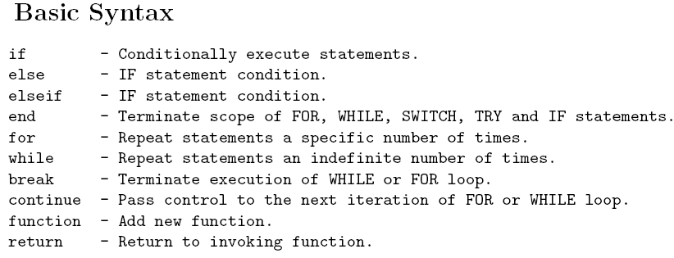
Fig: basic looping statements in MATLAB.

PLOTTING USING MATLAB
MATLAB provides very good 2D and 3D plots and 3D visualization functions.
List of commands used for plotting
plot
xlabel
ylabel
title
grid
axis
stem
subplot
- TWO DIMENTIONAL PLOT
To draw 2D plot plot command is used. The syntax is
plot(x,y)
x is a vector containing x-coordinates of the plot and
y is a vector containing x-coordinates of the plot.
To plot a curve of equation x=y^2 where x varies from 0 to 10. The commands will be
x=0 :1 : 10;
y=x..^2;
plot(x,y);
xlabel(‘x axis’); to give a name for x coordinate
ylabel(‘y axis’); to give a name for x coordinate
title(‘x Vs y plotting’); to give a name for x coordinate
grid on to get grid on the plotting
And the output will be
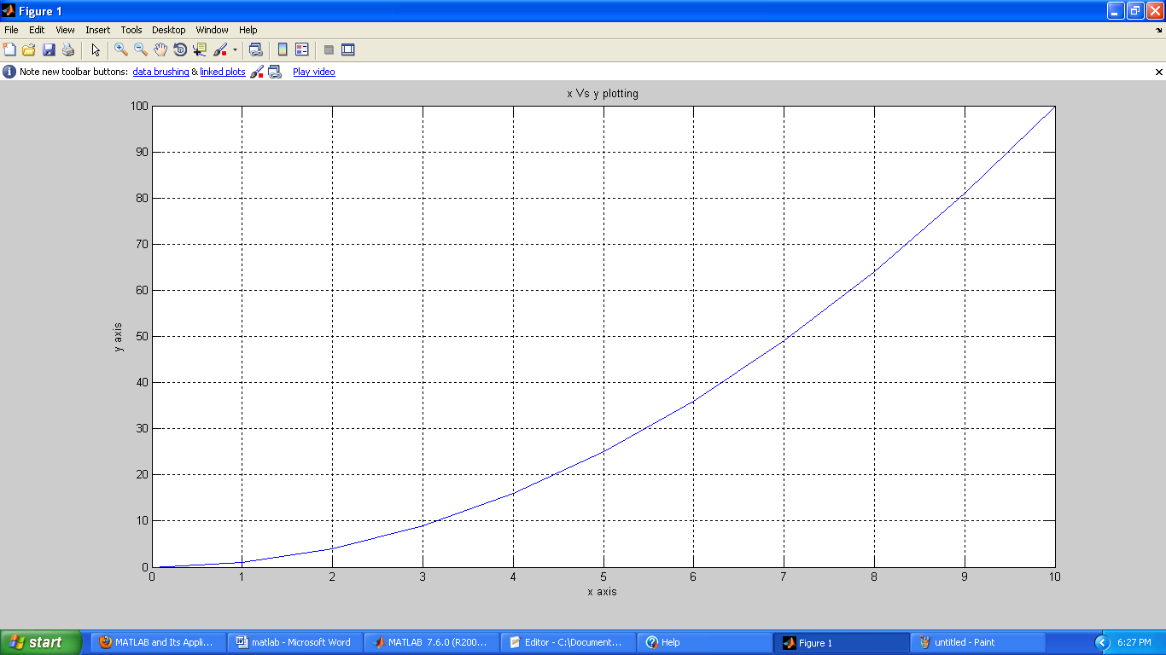
Figure 3.4: Plotting between 2 variables with labeling in MATLAB

We can use color and different type of marker style and line style in MATLAB as written in the box below
Table:3.1 Matlab graphics
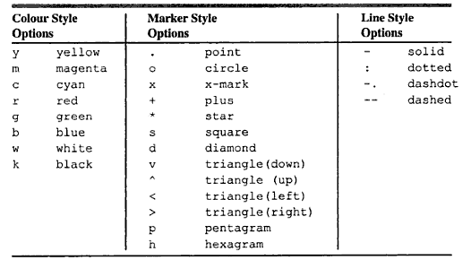
For example, plot(x,y,'--') uses a dashed line, plot(x,y,'*') uses * at all the points defined in t and y without connecting the points, and plot(x,y,'g') uses a solid green line. The options can also be used together, for example, plot(x,y,'g:') plots a dotted green line.
To plot two or more graphs on the same set of axes, use the command plot(x1,y1,x2,y2), which plots x1 versus t1 and x2 versus t2 or we can use HOLD command.
SERIAL COMMUNICATION USING MATLAB:
Serial communication is the most common low-level protocol for communicating between two or more devices. Normally, one device is a computer, while the other device can be a modem, a printer, another computer, microcontroller or a scientific instrument such as an oscilloscope or a function generator.
As the name suggests, the serial port sends and receives bytes of information in a serial fashion — one bit at a time. These bytes are transmitted using either a binary (numerical) format or a text format.
The serial port interface for connecting two devices is specified by the TIA/EIA-232C standard published by the Telecommunications Industry Association.
The original serial port interface standard was given by RS-232, which stands for Recommended Standard number 232. The term RS-232 is still in popular use, and is used in this guide when referring to a serial communication port that follows the TIA/EIA-232 standard. RS-232 defines these serial port characteristics:
- The maximum bit transfer rate and cable length
- The names, electrical characteristics, and functions of signals
- The mechanical connections and pin assignments
Primary communication is accomplished using three pins: the Transmit Data pin, the Receive Data pin, and the Ground pin. Other pins are available for data flow control, but are not required.
Other standards such as RS-485 define additional functionality such as higher bit transfer rates, longer cable lengths, and connections to as many as 256 devices.
The MATLAB serial port interface provides direct access to peripheral devices such as modems, printers, and scientific instruments that you connect to your computer's serial port. This interface is established through a serial port object. The serial port object supports functions and properties that allow you to
- Configure serial port communications
- Use serial port control pins
- Write and read data
- Use events and callbacks
- Record information to disk
Instrument Control Toolbox™ software provides additional serial port functionality. In addition to command-line access, this toolbox has a graphical tool called the Test & Measurement Tool, which allows you to communicate with, configure, and transfer data with your serial device without writing code. The Test & Measurement Tool generates MATLAB code for your serial device that you can later reuse to communicate with your device or to develop GUI-based applications. The toolbox includes additional serial I/O utility functions that facilitate object creation and configuration, instrument communication, and so on. With the toolbox you can communicate with GPIB- or VISA-compatible instruments.
Using MATLAB we can select COMPORT,BAUDRATE,START BIT,STOP BIT,PARITY BIT and DATA BIT for serial communication.
- Create a serial port object:
Obj=serial(‘port’,’propertyname’,propertyvalue)
Example: s = serial(‘COM1’,’BaudRate’,9600);
To specify properties during object creation
s = serial('COM2','BaudRate',9600,'DataBits',8 );
Obj = serial('port') creates a serial port object associated with the serial port specified by port. If port does not exist, or if it is in use, you will not be able to connect the serial port object to the device.
Port object name will depend upon the platform that the serial port is on. instrhwinfo ('serial') provides a list of available serial ports. This list is an example of serial constructors on different platforms:
- Open serial port:
fopen(‘obj’)
Example: fopen(s);
- Write in the serial port
fwriets(‘obj’,’variable name’); or fprintf(‘obj’,’variable name’);
Example:fwrites(s,str); or fprintf(s,str);
- Read from the serial port:
‘variable name’=fscanf(‘obj’); or
‘variable name’=freads(‘obj’); or to get binary data
‘variable name’=fgetc(‘obj’); or to get char data
‘variable name’=fgets(‘obj’); to get string data
Example
x=fscanf(s);
x=freads(s);
x=fgetc(s);
x=fgets(s);
- Close the serial port:
fclose(‘obj’);
Example:
fclose(s);
- Remove the serial port from memory:
delete(obj)
Example:
delete(s);
So using MATLAB we can get data serially from any other norms like another PC or Microcontroller and store them in an array and finally we can draw a real time plot using those values.

CHAPTER 4
PROJECT DESCRIPTION
4.1. SCHEMATIC DIAGRAM
In this chapter, schematic diagram and interfacing of Arduino microcontroller with each module is considered.
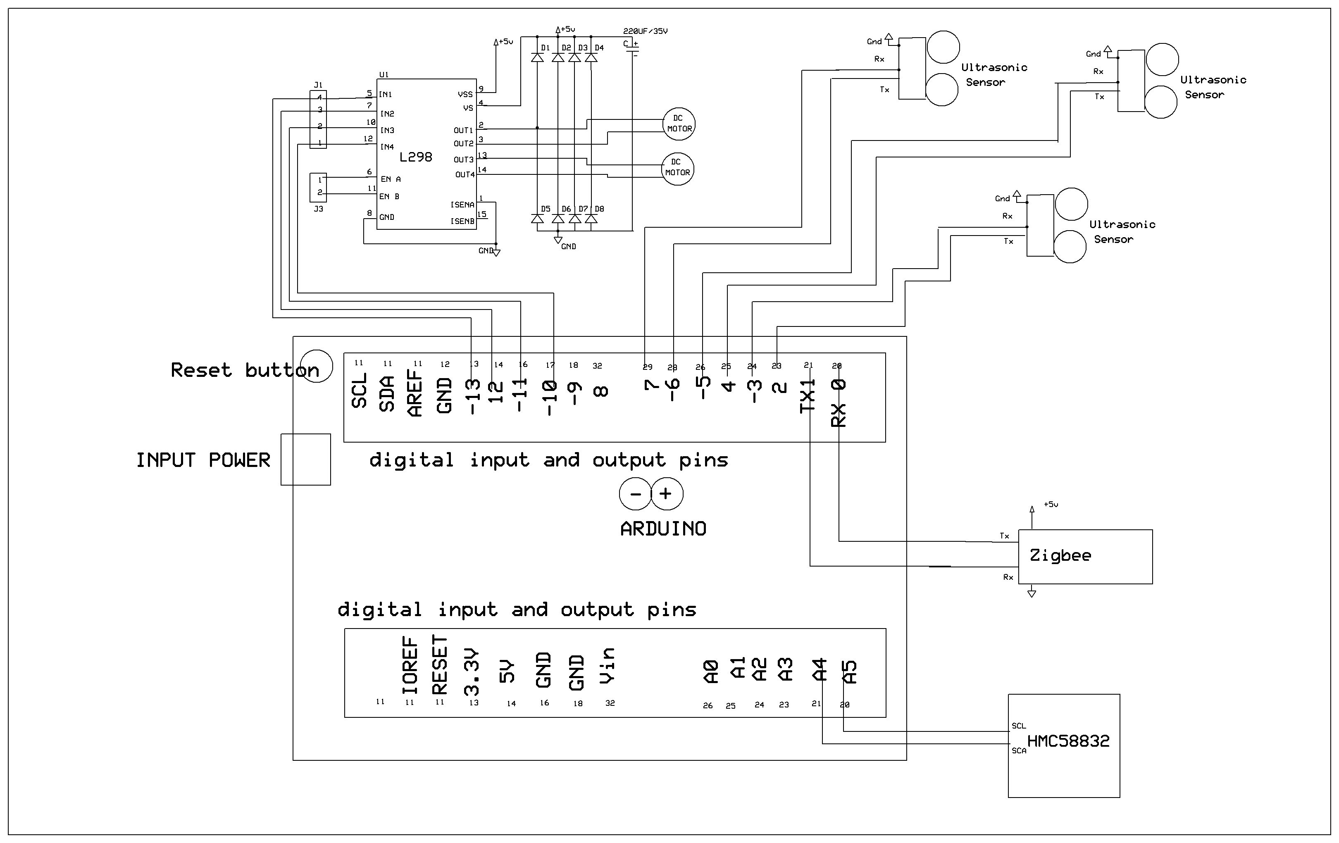
Figure 4.1: Schematic diagram

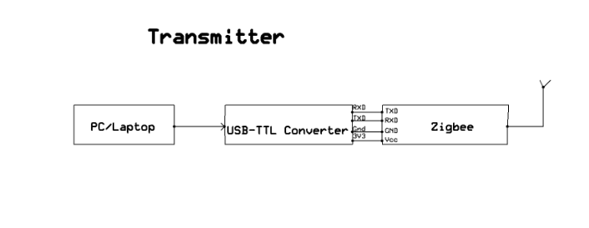
Figure 4.2: Receiver
The above schematic diagram Fig 4.1 explains the interfacing section of each component with micro controller. ULTRASONIC SENSORS are connected to 2 TO 7 pins of ARDUINO controller and HMC58832 also connected to PIN A4, A5 OF arduino micro controller. And also l298 connected to 10 to 13 pins, zigbee module is connected to pin 0 , 1. 12V battery for power supply in the given slot.
The Fig 4.2 describes the receiver part of zigbee which collects data required for 2d mapping from the robot wirelessly. The wire antenna is interfaced with pc using USB-TTL converter.

4.2. METHODOLOGY
The working of the robot is broadly represented in three vital operations:
- OBSTACLE DETECTION: Finding the safest path in the given environment with the ultra-sonic sensors in three different directions.
- OBSTACLE AVOIDANCE: Powering the respective motors to guide the robot away from the detected obstacle.
- Transmitting data required to map the path travelled by robot in 2D format using wireless communication.
- Process the received data in MATLAB software to get a comprehensible and clear 2D map.

4.2.1. OBSTACLE DETECTION
Using a special function get_distance(); we acquire the distances of obstacles present in three different directions. Whenever we face an obstacle in the forward direction, we have to choose whether to move the robot in left or in right direction depending on the obstacle distance in those directions. The direction with less distance between obstacle and robot is avoided.

4.2.2. OBSTACLE AVOIDANCE
We use a L298 motor driver to drive the four 12V motors. The robot is programmed in such a way that whenever it faces an obstacle, it turns 90 degrees either in left or in right direction. This is achieved in many methods using specified timings based on the RPM of the voltage. In our chosen method, the diagonal motors will have the same power supply i.e, the two diagonal motors are given same commands (forward or backward) at a time. When robot chooses to turn right, the bottom right and top left motors are run forward and other two motors are to run backward at the same time for a specified duration to achieve 90degrees turn. This method provides sharp and fast turning.
4.2.3. DATA TRANSMISSION
The data we use to map the path travelled by robot in 2D format are the distances of obstacles in three directions, the heading obtained by the digital compass and the data count. These are saperated by ‘+’ symbol to differentiate with other form of data using zigbee technology. This zigbee has an operational radius of 500-1000m. The heading direction referring North as 0° and the count indicating the instance.

4.2.4. DATA PROCESSING
A MATLAB program has been made to remove this ‘+’ symbols in between the data and
group together similar data and the distances from the left and right ultrasonic sensors are used
to map the surrounding obstacles as a robot is moving. The data given by the HMC5883L shows the
line in which the robot has moved.

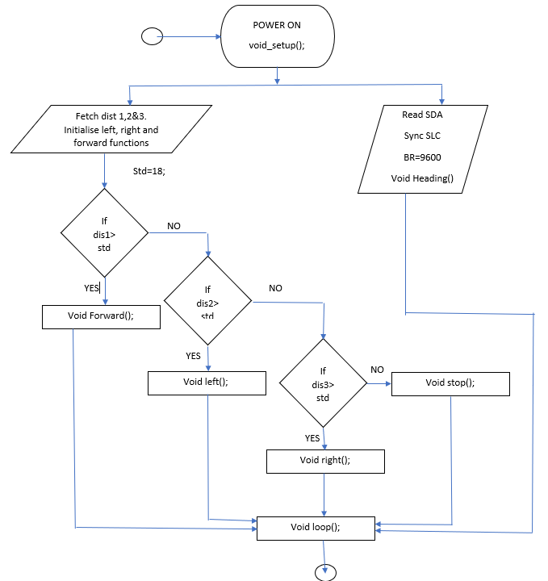
Figure:4.3: flowchart describing the behaviour of the robot when it is faces an obstacle .
when the power supply is on for the microcontroller and the other parts of the robot, the robot
start calculating the distance between optical and the robot in three directions that is left forward
and right directions. the distance is calculated easily using a special function get_distance();
when it was an obstacle in the forward direction it chooses weather to move in left or right by
comparing the distances in those directions. meanwhile in the same time digital compass HMC
5883L give the serial data about the direction of the robot in which it is heading. serial clock is
responsible for synchronisation between aurdino and digital compass.
zigbee transmitter transmits the data continuously to the PC which is used to map the
environment it around the robot during its travel in 2D format.

CHAPTER 5
RESULTS AND CONCLUSION
5.1. RESULTS
The project “SELF NAVIGATING AUTONOMOUS ROBOT WITH 2D-MAPPING USING ARDUINO” aims at developing an intelligently navigable Robot using ultrasonic sensors, Digital compass and wireless communication using ZIGBEE technology.
Obstacles have been successfully detected and avoided with coordination between ultrasonic sensors and motor driver with the desired 90 degree turn when an obstacle is faced.
The data transmitted by the zigbee transmitter on robot is successfully received by the zigbee receiver attached to the laptop in the format shown below which consists of heading angle, head count and the outputs of all the ultrasonic sensors
Figure5.1: data received by the laptop
The data received by the laptop is flawlessly processed in matlab and the 2D map is as shown below:

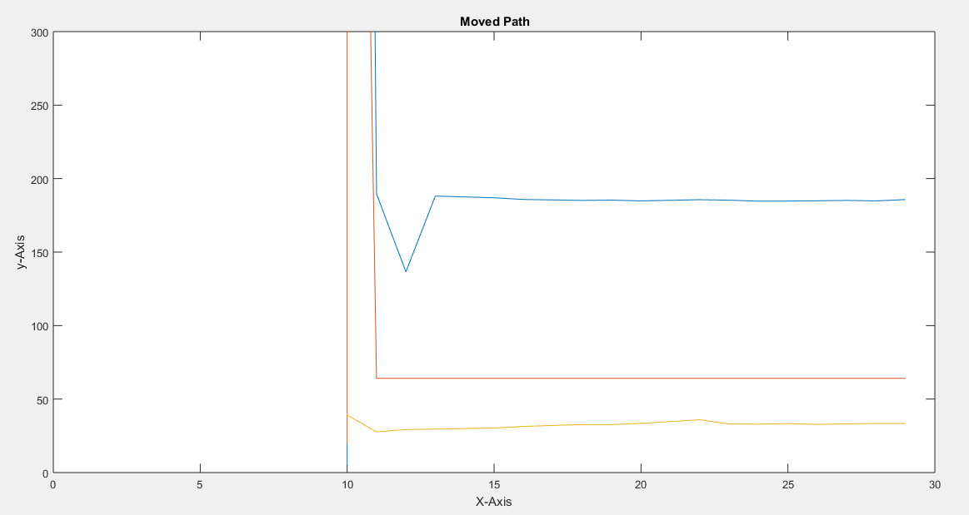
Figure 5.2:The result map
The design is taken care such that all the ultrasonic sensors are mounted on the top without any obstruction and the magnetic compass is isolated from other magnetic elements to avoid any disturbances in the output.

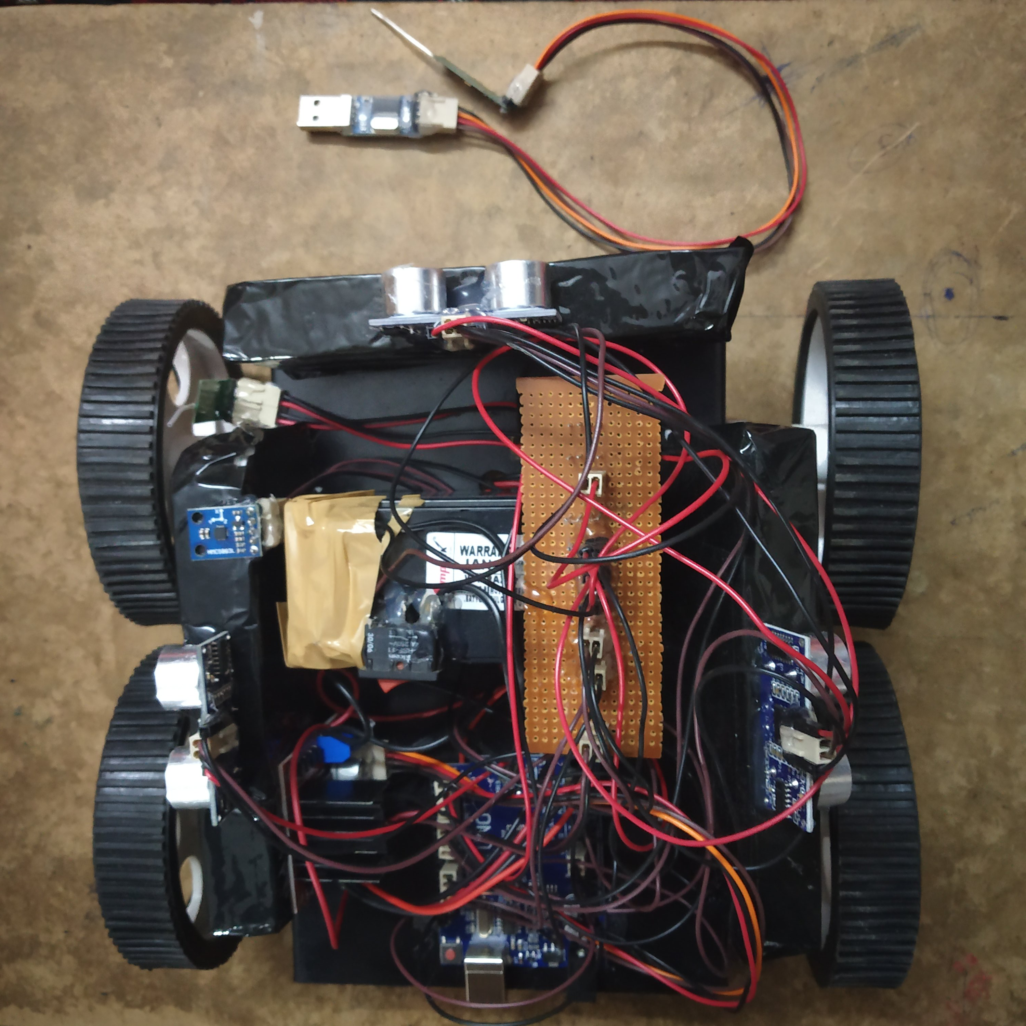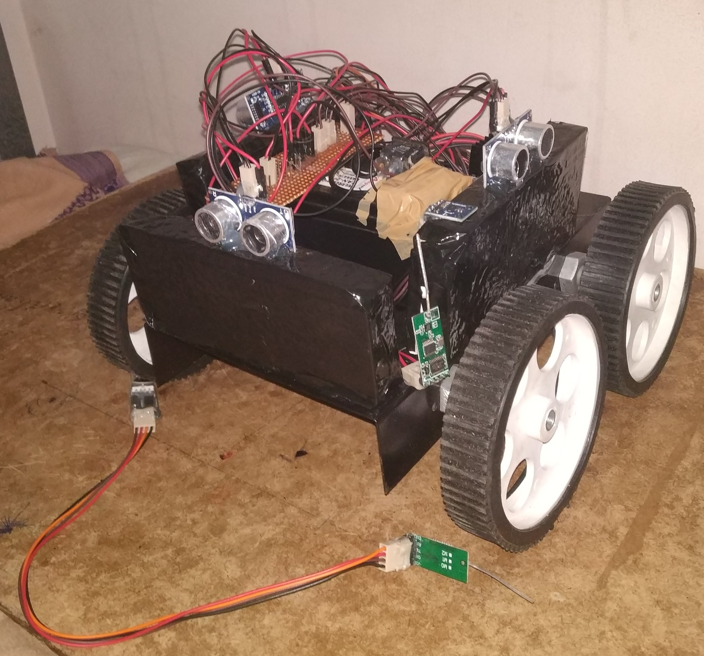
Figure: 5.3 ROBOT DESIGN

5.2 CONCLUSION
Integrating features of all the hardware components used have been developed in it. Presence of every module has been reasoned out and placed carefully, thus contributing to the best working of the unit. Secondly, the robot can cope up with rapidly changing real time parameters around it and thereby can be further developed for vital applications and sophisticated environment. Thus the project has been successfully designed and tested.

CHAPTER 6
LIMITATIONS AND FUTURE SCOPE
6.1 LIMITATIONS
- The robot is designed to take only exact 90 degree turns. It can’t face inclined environment.
- The obstacles need to be rigid and significantly large. The sensors detect the obstacles only when they are in its line of sight. The remaining portion of the robot is exposed to threat.
- 3D mapping of the environment is highly sophisticated in this project using only three ultra- sonic sensors
- Magnetic compass should be exactly parallel to the earth surface and should be isolated from other magnetic materials to avoid distrubances in heading.
6.2 FUTURE SCOPE
Our project “SELF NAVIGATING AUTONOMOUS ROBOT WITH 2D-MAPPING USING ARDUINO” aims at developing an intelligently navigable Robot using ultrasonic sensors and Digital compass. And wireless communication using ZIGBEE technology. To do this particular task using arduino written in embedded c language and PC with MATLAB.
Ultrasonic sensors (also known as transceivers when they both send and receive, but more generally called transducers) work on a principle similar to radar or sonar which evaluates attributes of a target by interpreting the echoes from radio or sound waves respectively. Ultrasonic sensors generate high frequency sound waves and evaluate the echo which is received back by the sensor. Sensors calculate the time interval between sending the signal and receiving the echo to determine the distance to an object.
By connecting bomb detector to the robot, we can send it to anywhere i.e (battle field, forests, coal mines, to anyplace) by using our personal computer and we can able to detect the bomb at field, here sensor detects the bomb and gives information to micro controller and it gives the information to transceiver and it sends the information to the personal computer.
By connecting temperature sensor to the robot we can get the temperature of dangerous zones in personal computer itself instead of sending human to there and facing problems at field we can send robot to there and sensor will detect the temperature and it gives information to the micro controller and micro controller gives the information to the transceiver from that we can get the data at pc side. By connecting smoke sensor to the robot we can get the information related concentration of smoke or gases in respective field’s i.e. (coal mines, dangerous zones, etc). sensor sense the information and it give to the micro controller and it gives to the transceiver and from that we get the information in personal computer.
By connecting corresponding instruments to the robot we can use it in agriculture for farming purpose. This robot can move either forward and backward and left and right depend upon our instructions so we can do some part of agriculture from pc only by using robot.
By connecting firing instrument and wireless camera to the robot we can fire the target from pc. Here by using camera we can see the opposite target and we can fire the target from personal computer by pressing selected button and we can easily handle the situations like Mumbai terrorist’s attack without loss of human life’s and we can decrease our soldiers effort too.

REFERENCES
- J. Guivant, E. Nebot, "Implementation of simultaneous navigation and mapping in large outdoor environments" in Robotics Research: The Tenth International Symposium, Springer, 2003.
- F. Ivis, "Calculating geographic distance: concepts and methods", Proceedings of the 19th Conference of Northeast SAS User Group, 2006.
- Douglas W. Gage, "A Brief History of Unmanned Ground Vehicle (UGV) Development Efforts", Unmanned Systems Magazine, vol. 13, no. 3, pp. 1-8, Dec. 1995.
- J. A. Oroko and G. N. Nyakoe. Obstacle Avoidance and Path Planning Schemes for Autonomous Navigation of a Mobile Robot: A Review, Mechanical Engineering conf. on Sustainable Research and Innovation, Vol. 4, May 2012, pp.315-318.
- K. Chu, M. Lee, M. Sunwoo, "Local Path Planning for Off-Road Autonomous Driving With Avoidance of Static Obstacles", IEEE Transactions on Intelligent Transportation Systems, vol. 13, no. 4, pp. 1599-1616, Dec. 2012.

Books referred:
- Raj kamal –Microcontrollers Architecture, Programming, Interfacing and System Design.
- Mazidi and Mazidi –Embedded Systems.
- PCB Design Tutorial –David.L.Jones.
- PIC Microcontroller Manual – Microchip.
- Embedded C –Michael.J.Pont.

APPENDIX

The program code which is dumped in the microcontroller of our project is shown below.
Arduino code :
#include <Wire.h>
#include <HMC5883.h>
#include <stdio.h>
#include <string.h>
#include <ctype.h>

int trigPin1 = 02;
int echoPin1 = 03;

int trigPin2 = 04;
int echoPin2 = 05;

int trigPin3 = 06;
int echoPin3 = 07;

int count = 10;

/*-------definning Outputs------*/
#define LM1 10 // left motor
#define LM2 11 // left motor
#define RM1 12 // right motor
#define RM2 13 // right motor

int flag = 0;

void forward()
{
digitalWrite(LM1, HIGH);
digitalWrite(LM2, LOW);
digitalWrite(RM1, HIGH);
digitalWrite(RM2, LOW);
}

void backward()
{

digitalWrite(LM1, LOW);
digitalWrite(LM2, HIGH);
digitalWrite(RM1, LOW);
digitalWrite(RM2, HIGH);
}

void left()
{

digitalWrite(LM1, HIGH);
digitalWrite(LM2, LOW);
digitalWrite(RM1, LOW);
digitalWrite(RM2, HIGH);
}

void right()
{

digitalWrite(LM1, LOW);
digitalWrite(LM2, HIGH);
digitalWrite(RM1, HIGH);
digitalWrite(RM2, LOW);
}

void rstop()
{

digitalWrite(LM1, LOW);
digitalWrite(LM2, LOW);
digitalWrite(RM1, LOW);
digitalWrite(RM2, LOW);
}

void setup()
{
Wire.begin();
Serial.begin(9600);

pinMode(trigPin1, OUTPUT); //SR04 trig
pinMode(echoPin1, INPUT); //SR04 echo

pinMode(trigPin2, OUTPUT); //SR04 trig
pinMode(echoPin2, INPUT); //SR04 echo

pinMode(trigPin3, OUTPUT); //SR04 trig
pinMode(echoPin3, INPUT); //SR04 echo

pinMode(LM1, OUTPUT);
pinMode(LM2, OUTPUT);
pinMode(RM1, OUTPUT);
pinMode(RM2, OUTPUT);

hmc.init();
}

void loop()
{
int x, y, z;
int azimuth;
hmc.read(&x, &y, &z,&azimuth);
String sc="+";

get_dist1();
get_dist2();
get_dist3();

count++;

String s1=String(targetDistance1);
String s2=String(targetDistance2);
String s3=String(targetDistance3);
String head=String((int)azimuth);
String scount= String(count) ;
String s=s1+sc+s2+sc+s3+sc+head+sc+scount+sc;
Serial.print(s);
Serial.println();

get_dist1();
get_dist2();
get_dist3();

if(targetDistance2 < 30)
{
rstop();
delay (160);

get_dist1();
delay (10);
get_dist2();
delay (10);
get_dist3();
delay (10);

if(targetDistance1 > 30)
{
left();
delay (1600);
rstop();
delay (160);
}

else if(targetDistance3 > 30)
{
right();
delay (1600);
rstop();
delay (160);

}
delay (160);
}

else
{
forward();
cd='f';
delay (1000);
rstop();
delay (160);
}

if(count > 28)
{
rstop();
while(1);
}

delay(100);

}

Matlab code:
%
clear; close all; clc;
% Start Here
COM_Port = getAvailableComPort();
s = serial(COM_Port,'BaudRate',9600);
fopen(s)
disp('Reading...');
count = 1;
fopen('data.txt', 'w'); % This portion of code writes the number plate
while 1
ard = fscanf(s,'%s')
C = strsplit(ard,'+');
fid = fopen('data.txt', 'a'); % This portion of code writes the number plate
fprintf(fid,'%s\n',ard); % to the text file, if executed a notepad file with the

if(count > 20)
disp('Break...');
fclose(s);
break;
end
count = count+1;
end
fid=fopen('data.txt');
t = textscan(fid,'%f%f%f%f%f', 'Delimiter','+');
fclose(fid);
w=t{1};
x=t{2};
y=t{3};
z=t{4};
q = t{5};
figure(1)
%%%%%%%%%%%%%2-D Plot%%%%%%%%%%%%%%%%%%%%%%
plot(q,w)
% grid
hold on
plot(q,x)
hold on
plot(q,y)
ylim([0 300])
xlim([0 30])
%%%%%%%%%%%%%%%%%%%%%%%%%%%%%%%%%%%%%%%%%%%
% %%%%%%%%%%%%%3-D Plot%%%%%%%%%%%%%%%%%%%
%
% plot3(q,w,y)
% % grid
% hold on
% ylim([0 300])
% xlim([0 30])
% zlim([0 300])
% %%%%%%%%%%%%%%%%%%%%%%%%%%%%%%%%%%%%%%%%%%%%
title('\bf Moved Path')
xlabel('X-Axis')
ylabel('y-Axis')

